Aleksas Murauskas

260718389

COMP 424

Homework 2

Question 1: Constraint Satisfaction

Find a 10-digit number such that the first digit is the number of zeros in the number, the second digit is the number of ones in the number, …, and the tenth digit is the number of nines in the number. The first digit must be non-zero

1. Formulate this problem as a CSP. List the variables, their domains, and the constraints. Draw the constraint graph.

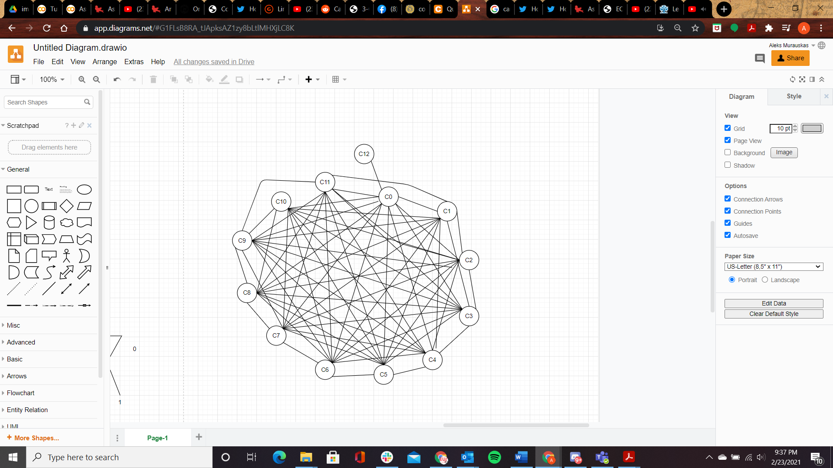

1. Show the first ten steps of backtracking search on this problem, where you order the variables from the first digit to the last digit, and the values from lowest to highest. Recall that backtracking search uses a depth-first strategy to expand the search tree.

Expand nodes until the found node is no longer valid, then backtrack (DFS)

|  |  |  |  |  |  |  |  |  |  |  |  |
| --- | --- | --- | --- | --- | --- | --- | --- | --- | --- | --- | --- |
| Iteration |  |  |  |  |  |  |  |  |  |  | Pass Constraints? |
| 1 | 1 | TBD | TBD | TBD | TBD | TBD | TBD | TBD | TBD | TBD | Yes |
| 2 | 1 | 0 | TBD | TBD | TBD | TBD | TBD | TBD | TBD | TBD | No |
| 3 | 1 | 1 | TBD | TBD | TBD | TBD | TBD | TBD | TBD | TBD | No |
| 4 | 1 | 2 | TBD | TBD | TBD | TBD | TBD | TBD | TBD | TBD | Yes |
| 5 | 1 | 2 | 0 | TBD | TBD | TBD | TBD | TBD | TBD | TBD | No |
| 6 | 1 | 2 | 1 | TBD | TBD | TBD | TBD | TBD | TBD | TBD | Yes |
| 7 | 1 | 2 | 1 | 0 | TBD | TBD | TBD | TBD | TBD | TBD | Yes |
| 8 | 1 | 2 | 1 | 0 | 0 | TBD | TBD | TBD | TBD | TBD | No |
| 9 | 1 | 2 | 1 | 0 | 1 | TBD | TBD | TBD | TBD | TBD | No |
| 10 | 1 | 2 | 1 | 0 | 2 | TBD | TBD | TBD | TBD | TBD | No |

1. Show the first ten steps of backtracking search on this problem with one-step forward checking, where you order the variables from the first digit to the last digit, and the values from lowest to highest?

If the next node has no valid children, skip it.

|  |  |  |  |  |  |  |  |  |  |  |  |
| --- | --- | --- | --- | --- | --- | --- | --- | --- | --- | --- | --- |
| Iteration |  |  |  |  |  |  |  |  |  |  | Pass Constraints? |
| 1 | 1 | TBD | TBD | TBD | TBD | TBD | TBD | TBD | TBD | TBD | Yes |
| 2 | 1 | 2 | TBD | TBD | TBD | TBD | TBD | TBD | TBD | TBD | Yes |
| 3 | 1 | 2 | 1 | TBD | TBD | TBD | TBD | TBD | TBD | TBD | Yes |
| 4 | 1 | 2 | 1 | 0 | TBD | TBD | TBD | TBD | TBD | TBD | Yes |
| 5 | 1 | 2 | 2 | TBD | TBD | TBD | TBD | TBD | TBD | TBD | Yes |
| 6 | 1 | 2 | 2 | 0 | TBD | TBD | TBD | TBD | TBD | TBD | Yes |
| 7 | 1 | 2 | 3 | TBD | TBD | TBD | TBD | TBD | TBD | TBD | Yes |
| 8 | 1 | 2 | 3 | 0 | TBD | TBD | TBD | TBD | TBD | TBD | Yes |
| 9 | 1 | 2 | 4 | TBD | TBD | TBD | TBD | TBD | TBD | TBD | Yes |
| 10 | 1 | 3 | TBD | TBD | TDB | TBD | TBD | TBD | TBD | TBD | Yes |

Question 2: Search and Game Playing

You are playing rock-paper-scissors with your friend, but with a twist. The game now consists of three rounds, and each round, players may not play something that they have played before. So, if you play rock the first round, you cannot play it again in rounds two and three. The winner of the game is the player who wins the most rounds.

1. Draw the AND-OR tree associated with this game.

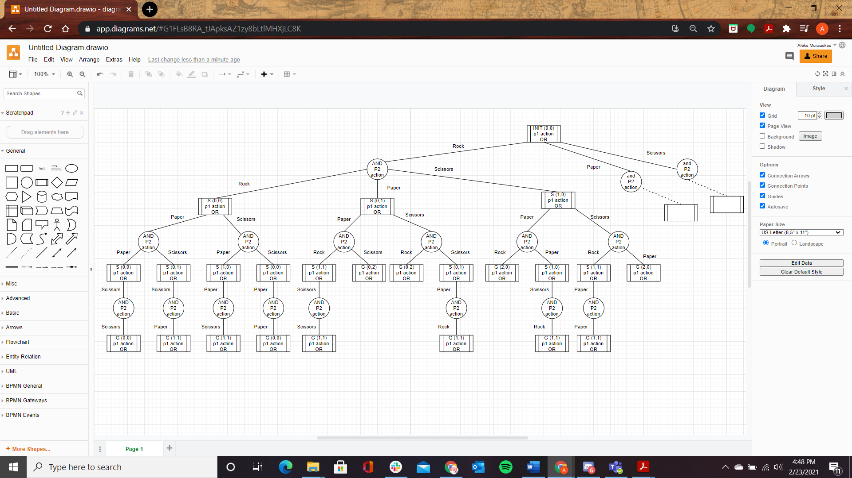

1. In the first round, you play rock and your friend plays scissors, giving you the first win. Can you guarantee a win of the game overall? Explain by extracting a contingency plan from the AND-OR tree above.

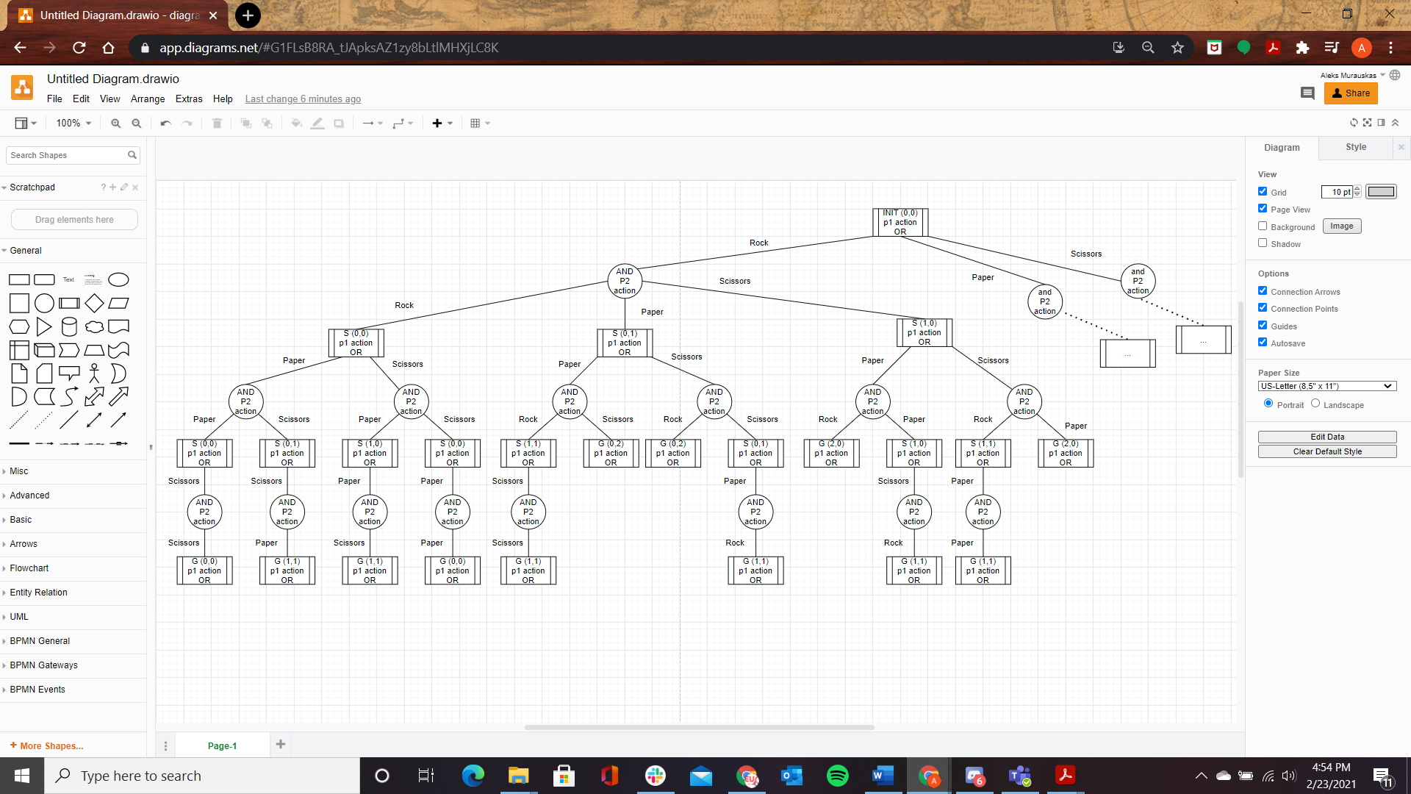

If we follow the above tree, player 1 (myself) Is winning by one. There are Four possible end states available from the current states, two are wins and two are draws. There is a 50-50 chance of winning or the result of the game being a draw. Since I have received one win, it is impossible for player 1 to lose the game. There is no way to guarantee a win. The odds of winning by throwing out Paper or Scissors are equal.

1. Check your answer by reformulating the AND-OR tree into a game tree where you apply the Minimax algorithm.

Let the following values: Loss state = -1, tie state =0, win state = 1

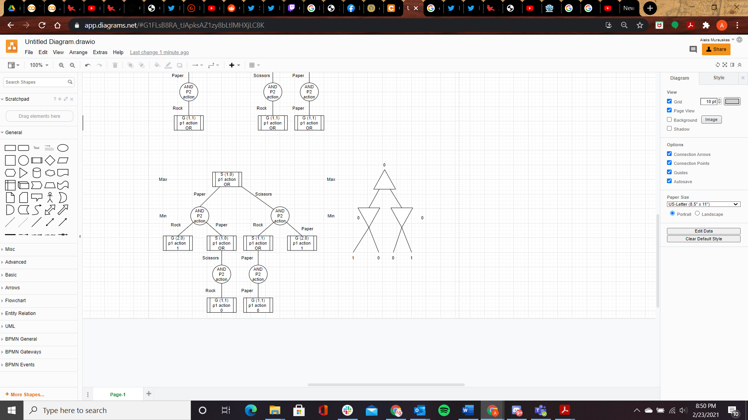

Question 3: Propositional Logic

1. How many models are there for each of the following statements in propositional logic?

If C is 1, then R is 1. Otherwise, A and B must be 1 in order

|  |  |  |  |
| --- | --- | --- | --- |
| A | B | C | R |
| 0 | 0 | 0 | 0 |
| 0 | 0 | 1 | 1 |
| 0 | 1 | 0 | 0 |
| 0 | 1 | 1 | 1 |
| 1 | 0 | 0 | 0 |
| 1 | 0 | 1 | 1 |
| 1 | 1 | 0 | 1 |
| 1 | 1 | 1 | 1 |

From this Truth Table above there are 5 Models

|  |  |  |
| --- | --- | --- |
| A | B | C |
| 0 | 0 | 0 |
| 0 | 1 | 0 |
| 1 | 0 | 0 |
| 1 | 1 | 0 |

0 Models This is a contradiction

|  |  |  |  |  |
| --- | --- | --- | --- | --- |
| A | B | C | D | R |
| 0 | 0 | 0 | 0 | 1 |
| 0 | 0 | 0 | 1 | 1 |
| 0 | 0 | 1 | 0 | 1 |
| 0 | 0 | 1 | 1 | 1 |
| 0 | 1 | 0 | 0 | 1 |
| 0 | 1 | 0 | 1 | 1 |
| 0 | 1 | 1 | 0 | 1 |
| 0 | 1 | 1 | 1 | 1 |
| 1 | 0 | 0 | 0 | 1 |
| 1 | 0 | 0 | 1 | 1 |
| 1 | 0 | 1 | 0 | 1 |
| 1 | 0 | 1 | 1 | 1 |
| 1 | 1 | 0 | 0 | 1 |
| 1 | 1 | 0 | 1 | 1 |
| 1 | 1 | 1 | 0 | 1 |
| 1 | 1 | 1 | 1 | 1 |

This is a tautology. There are 2^4=16 Models.

1. State whether each of the following is valid, unsatisfiable, or satisfiable. Support your answers with a truth table or a proof using rules of logical inference.